

PROPOSAL DOCUMENT

Vulnerability Assessment &
Penetration Testing (VAPT)
Proposal

Nam-mic Payment Solutions (Pty) Ltd

20 August 2025

Prepared by Sautech (Pty) Ltd

TABLE OF CONTENTS

1 Executive summary 4
2 Objectives 4
3 scope of testing 4
3.1 In-Scope 4
3.2 Out of Scope 5
3.3 Testing Constraints & Safeguards 5
4 Methodologies / Technology used 5
4.1 Nmap / Zenmap 5
4.2 Nessus 6
4.3 Greenbone Enterprise 6
4.4 Kali Linux 6
4.5 Hydra / Brute Force 7
4.6 OWASP 8
4.7 Social Engineering Attacks 8
STAY ONE STEP AHEAD OF ATTACKERS 9
5 Examples of Attack and results 9
5.1 Vulnerability Scan 9
5.2 Brute Force 10
5.3 Port Mapping 10
5.4 Web Application Testing 11
5.5 Database Exploitation 11
5.6 Active Directory 11
5.7 Wireless Network 12
6 Project PLan 12
6.1 Project Initiation 12
6.2 Reconnaissance 13
6.3 Vulnerability Scanning and Assessment 13
6.4 Exploitation 13
6.5 Privilege Escalation 13
6.6 Lateral Movement 13
6.7 Data Security & Exfiltration 13
6.8 Backup & Recovery Testing 14
6.9 Reporting & Risk Analysis 14
6.10 Remediation & Follow-Up 14
7 DELIVERABLES AND OUTCOMES 14
7.1 Primary Deliverable 14
7.2 Report Component’s 14
8 Risk Analysis for Cyber Penetration Testing Proposal 15
8.1 Objective 15
8.2 Risk Identification 15
8.3 Risk Assessment 16
8.4 Risk Mitigation 16
8.5 Risk Monitoring and Review 16
9 RESOURCE REQUIREMENTS 16
9.1 Assessment Areas and Assigned Resources 17
9.2 Detailed Recourse Requirements 17
10 Key Personnel 17
11 Cost Analysis 17
12 TERMS & CONDITIONS 18
12.1 Confidentiality 18
12.2 Client Responsibilities 18
12.3 Testing Boundaries 18
12.4 Liability 18
12.5 Compliance 18
12.6 Reporting and Ownership 18
12.7 Payment Terms 19
12.8 Validity 19
13 References / APENDICES 19
14 CONCLUSION 19
15 AUTHORISATION 19

Executive summary

Nam-mic Payment Solutions (Pty) Ltd, a licensed entity under the Bank of Namibia, requires a comprehensive penetration test across its Banking and Vending platforms to ensure compliance with PSD-12 regulations and to strengthen its cybersecurity posture. Sautech proposes a structured Vulnerability Assessment and Penetration Testing (VAPT) engagement aligned with industry best practices and Nam-mic’s compliance obligations.

Objectives

- Analyse and understand security threats and vulnerabilities across Nam-mic’s infrastructure.
- Identify potential impact and compliance gaps with PSD-12 requirements.
- Evaluate response, recovery, and resumption capabilities in line with regulatory standards.
- Ensure compliance with PSD-12 risk indicators: 99.9% uptime, 2-hour recovery time objective, 5-minute recovery point objective.
- Provide actionable recommendations and prioritised remediation roadmap.
- Strengthen overall security posture of Nam-mic’s payment ecosystem.

scope of testing

In-Scope

- External IP Range: 41.190.84.130 – 41.190.84.158 (28 addresses).
A full penetration test will be conducted against Nam-mic’s allocated public IP range to identify external-facing vulnerabilities exploitable from the internet.
- Web applications & portals (Banking & Vending).
Testing of Nam-mic’s customer-facing applications to identify vulnerabilities such as SQL injection, cross-site scripting, authentication flaws, and business logic weaknesses.
- Payment processing endpoints and API gateways.
Assessment of APIs and transaction processing endpoints to validate security of payment data flows and protection against unauthorized access or tampering.
- Authentication mechanisms.
Testing of login systems, multi-factor authentication, and session management to evaluate resistance to brute force, credential stuffing, and bypass techniques.
- Database systems where access is provided.
Evaluation of database security, configuration, encryption, and access controls where credentials are available, ensuring protection of sensitive financial data.
- Backup and recovery systems.
Verification of backup and recovery configurations, including validation of encryption, retention, and recovery objectives as per PSD-12 compliance requirements.
- Network infrastructure components.
Assessment of routers, switches, and firewalls for misconfigurations, outdated firmware, or weak access controls that could compromise the internal network.
- Vulnerability assessments across all exposed applications and open ports.
Systematic scanning and manual verification of vulnerabilities in applications and services exposed on open ports to reduce the attack surface.
- Testing aligned with OWASP Top 10 and Greenbone enterprise vulnerability management.
Application of OWASP Top 10 principles for web application testing combined with Greenbone vulnerability management for automated detection and compliance reporting.
- Validation of security posture with geolocation restrictions disabled (geo-locking).
Testing security resilience when geo-locking is disabled, ensuring no over-reliance on geographic access controls for protection.
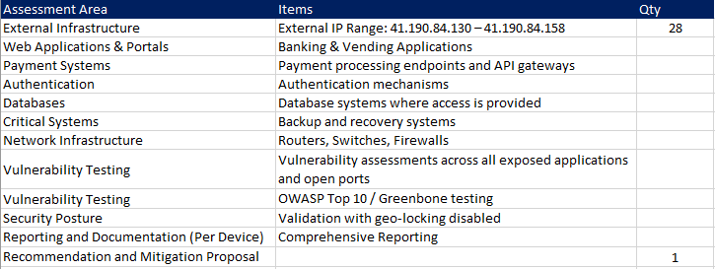

Out of Scope

The following areas are explicitly excluded from this engagement:
- Physical Security Testing (site/office security assessments).
- Social Engineering Attacks (phishing, vishing, or insider manipulation attempts).
- Denial-of-Service (DoS / DDoS) Testing on live production systems.
- Any systems not explicitly listed in the approved scope.

Testing Constraints & Safeguards
- Testing will only be conducted on the approved in-scope systems listed above.
- No testing will be performed on excluded systems or services.
- All activities will be executed in a controlled manner to avoid disruption to live business operations.
- Client approvals will be obtained prior to initiating any intrusive testing methods.

Methodologies / Technology used

Sautech will apply a combination of automated and manual audit techniques to thoroughly evaluate Nam-mic’s systems. These methodologies are designed to identify, exploit, and validate vulnerabilities while ensuring compliance with PSD-12, OWASP, and international security standards. The techniques include the following:

Nmap / Zenmap

Port scanning, network mapping, identification of open ports and misconfigurations.
Nmap, short for Network Mapper, is a tool used for vulnerability checking, port scanning and, of course, network mapping. Despite being created back in 1997, Nmap remains the gold standard against which all other similar tools either commercial or open source, are judged.

To deploy Nmap, users originally had to have some advanced programming skills, with the introduction of the Zenmap tool for Nmap, which adds a graphical interface that makes launching the program and analysing the returned output it generates much more accessible.

Nessus

Comprehensive vulnerability scanning with 1200+ checks for known exploits Nessus is a remote security scanning tool, which scans a computer and raises an alert if it discovers any vulnerabilities that malicious hackers could use to gain access to any computer you have connected to a network. It does this by running over 1200 checks on a given computer, testing to see if any of these attacks could be used to break into the computer or otherwise harm it.

Greenbone Enterprise
Automated vulnerability management and compliance reporting. Greenbone is the world’s most widely used vulnerability management provider.
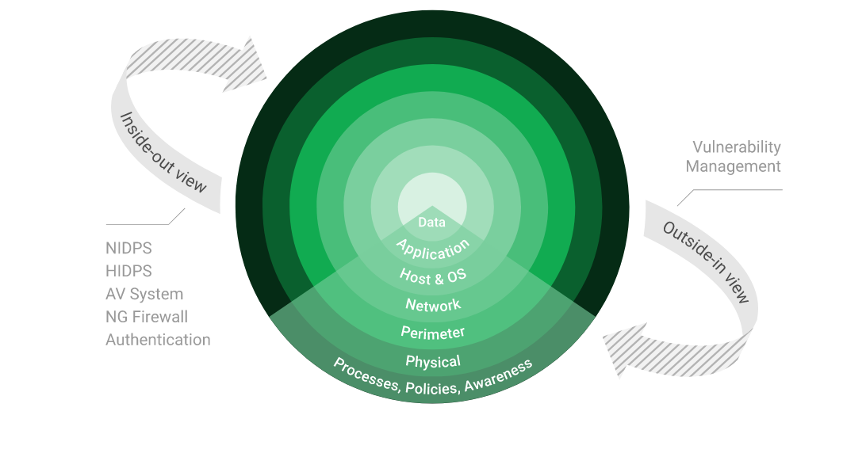

Kali Linux

Exploitation framework including Hydra, Crunch, CUpp for brute force and attack simulations.
- Kali Linux (formerly known as BackTrack Linux) is an open-source, Debian-based Linux distribution aimed at advanced Penetration Testing and Security Auditing. It does this by providing common tools, configurations, and automations which allows the user to focus on the task that needs to be completed, not the surrounding activity.
- Kali Linux contains industry specific modifications as well as several hundred tools targeted towards various Information Security tasks, such as Penetration Testing, Security Research, Computer Forensics, Reverse Engineering, Vulnerability Management and Red Team Testing.
- Kali Linux is a multi-platform solution, accessible and freely available to information security professionals and hobbyists.
- Kali Linux Features: more than 600 penetration testing tools included. After reviewing every tool that was included in BackTrack, we eliminated a great number of tools that either simply did not work or which duplicated other tools that provided the same or similar functionality. Details on what’s included are on the Kali Tools site.
- Free (as in beer) and always will be: Kali Linux, like BackTrack, is completely free of charge and always will be. You will never, ever have to pay for Kali Linux.
- Open source Git tree: We are committed to the open source development model and our development tree is available for all to see. All of the source code which goes into Kali Linux is available for anyone who wants to tweak or rebuild packages to suit their specific needs.
- FHS compliant: Kali adheres to the Filesystem Hierarchy Standard, allowing Linux users to easily locate binaries, support files, libraries, etc.
- Wide-ranging wireless device support: A regular sticking point with Linux distributions has been support for wireless interfaces. We have built Kali Linux to support as many wireless devices as we possibly can, allowing it to run properly on a wide variety of hardware and making it compatible with numerous USB and other wireless devices.
- Custom kernel, patched for injection: As penetration testers, the development team often needs to do wireless assessments, so our kernel has the latest injection patches included.

- Developed in a secure environment: The Kali Linux team is made up of a small group of individuals who are the only ones trusted to commit packages and interact with the repositories, all of which is done using multiple secure protocols.
- GPG signed packages and repositories: Every package in Kali Linux is signed by each individual developer who built and committed it, and the repositories subsequently sign the packages as well.
- Multi-language support: Although penetration tools tend to be written in English, we have ensured that Kali includes true multilingual support, allowing more users to operate in their native language and locate the tools they need for the job.
- Completely customizable: We thoroughly understand that not everyone will agree with our design decisions, so we have made it as easy as possible for our more adventurous users to customize Kali Linux to their liking, all the way down to the kernel.
- ARMEL and ARMHF support: Since ARM-based single-board systems like the Raspberry Pi and BeagleBone Black, among others, are becoming more and more prevalent and inexpensive, we knew that Kali’s ARM support would need to be as robust as we could manage, with fully working installations for both ARMEL and ARMHF systems. Kali Linux is available on a wide range of ARM devices and has ARM repositories integrated with the mainline distribution so tools for ARM are updated in conjunction with the rest of the distribution.
- Kali Linux is specifically tailored to the needs of penetration testing professionals, and therefore all documentation on this site assumes prior knowledge of, and familiarity with, the Linux operating system in general.

Hydra / Brute Force

Used to simulate brute force attacks against authentication portals (SSH, RDP, web logins).
- A brute force attack is a hacking method that uses trial and error to crack passwords, login credentials, and encryption keys. It is a simple yet reliable tactic for gaining unauthorized access to individual accounts and organizations’ systems and networks. The hacker tries multiple usernames and passwords, often using a computer to test a wide range of combinations, until they find the correct login information.
- The name "brute force" comes from attackers using excessively forceful attempts to gain access to user accounts. Despite being an old cyberattack method, brute force attacks are tried and tested and remain a popular tactic with hackers

4.5.1 Applications in Brute Force Include:
Hydra is a parallelized network login cracker built in various operating systems like Kali Linux, Parrot and other major penetration testing environments. Hydra works by using different approaches to perform brute-force attacks in order to guess the right username and password combination. Hydra is commonly used by penetration testers together with a set of programmes like crunch,[2] cupp[3] etc, which are used to generate wordlists. Hydra is then used to test the attacks using the wordlists that these programmes created.

Over 1 Million + Username and password combos are used to Brute force application like RDP, SSH etc.

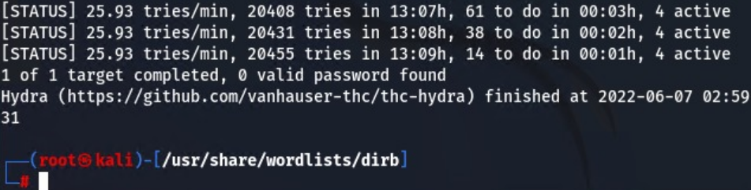

OWASP

Framework for identifying web application vulnerabilities (SQLi, XSS, CSRF, authentication flaws).

The Open Web Application Security Project (OWASP) is an online community that produces freely-available articles, methodologies, documentation, tools, and technologies in the field of web application security. The Open Web Application Security Project (OWASP) provides free and open resources. It is led by a non-profit called The OWASP Foundation. The OWASP Top 10 - 2021 is the published result of recent research based on comprehensive data compiled from over 40 partner organizations.

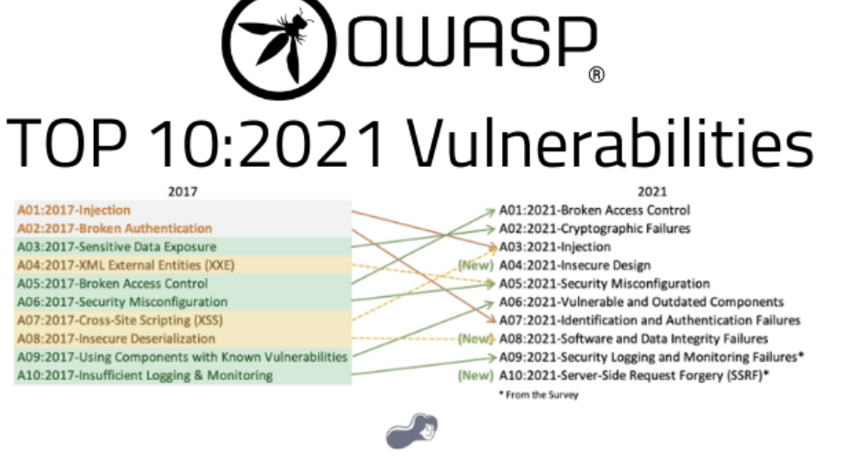

Social Engineering Attacks

This engagement excludes social engineering tests as per Nam-mic’s request. Should these services be required in future, Sautech has the capability to conduct controlled phishing, pretexting, baiting, and impersonation assessments.
Testing cyber social engineering is a critical step in assessing the security posture of an organization or individual.
- Phishing: This involves sending deceptive emails or messages that appear to be from a trustworthy source, such as a reputable company or a colleague. Phishing emails often contain malicious links or attachments designed to trick recipients into revealing sensitive information or executing malware.
- Pretexting: In pretexting, an attacker creates a false identity or scenario to gain the trust of the target. They may pose as a co-worker, a service provider, or an authority figure to manipulate individuals into providing sensitive information or granting unauthorized access.
- Baiting: Baiting involves enticing a target with something of value, such as a free USB drive or an appealing file download. The bait is typically infected with malware that compromises the target's system when accessed.
- Tailgating/Piggybacking: This tactic relies on exploiting the natural human tendency to hold the door open for others. An attacker gains physical access to a secure area by closely following an authorized person through an entry point, leveraging their trust.
- Impersonation: Attackers may impersonate someone of authority, such as an executive, IT administrator, or law enforcement officer, to manipulate individuals into providing sensitive information, granting access, or complying with their requests.
- Reverse Social Engineering: Instead of the attacker initiating contact, they trick the target into contacting them. This tactic often involves placing a seemingly harmless item, such as a USB drive or lost smartphone, in a public space, hoping that the target will connect it to their system, inadvertently giving the attacker access.
- Water-holing: In water-holing attacks, the attacker compromises websites frequently visited by the target group. By exploiting vulnerabilities in these websites, the attacker can deliver malware or gather information when the target visits the compromised site.

STAY ONE STEP AHEAD OF ATTACKERS

IT security is a process – Open Source vulnerability management provides the foundation. Once you know where the chinks are in your armor, you can do something about them.

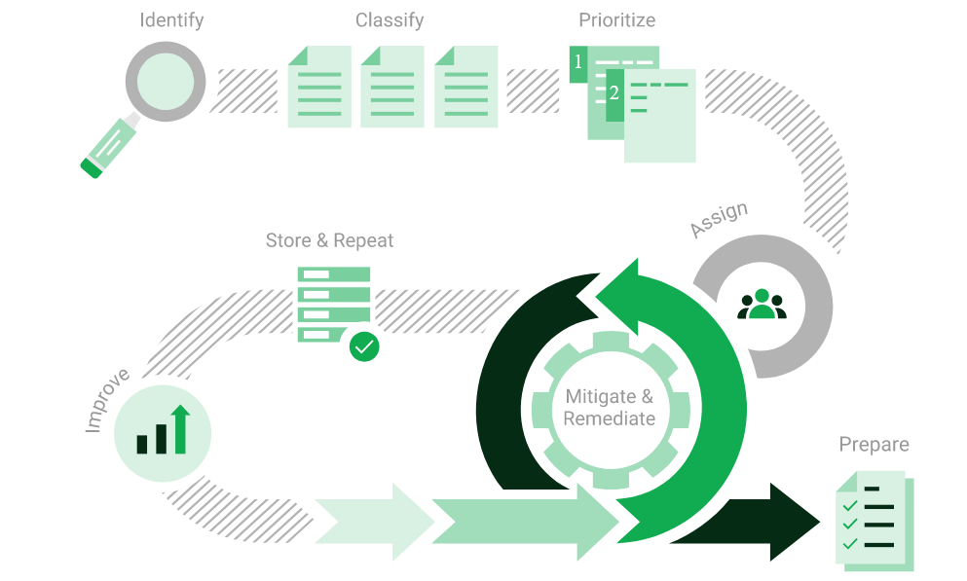

The process – from recognition to remedy and monitoring – represents a continuous cycle. You’ll always be one step ahead of attackers.

Examples of Attack and results

Vulnerability Scan

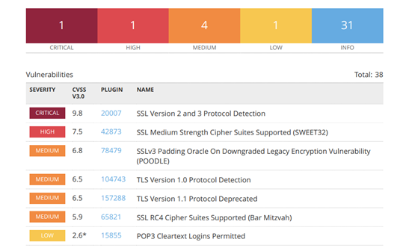

Brute Force

Testing authentication portals using Hydra with large-scale wordlists.
Randomised usernames with a word list containing more than 1+ million words and common passwords were brute forced SSH’s onto the server using Hydra.

Hydra works by using different approaches to perform brute-force attacks in order to guess the right username and password combination. Hydra is commonly used by penetration testers together with a set of programmes like crunch, cupp etc, which are used to generate wordlists.

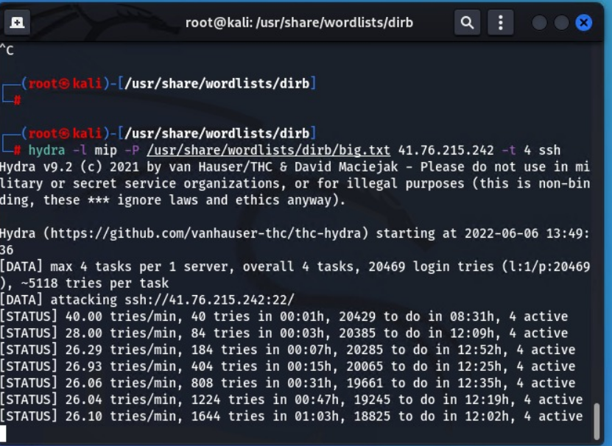

Port Mapping

Using Nmap to identify open ports, misconfigurations, and potential attack vectors.
Nmap can be used by hackers to gain access to uncontrolled ports on a system. All a hacker would need to do to successfully get into a targeted system would be to run Nmap on that system, look for vulnerabilities, and figure out how to exploit them.

The below screenshot demonstrates the open network port mapping:

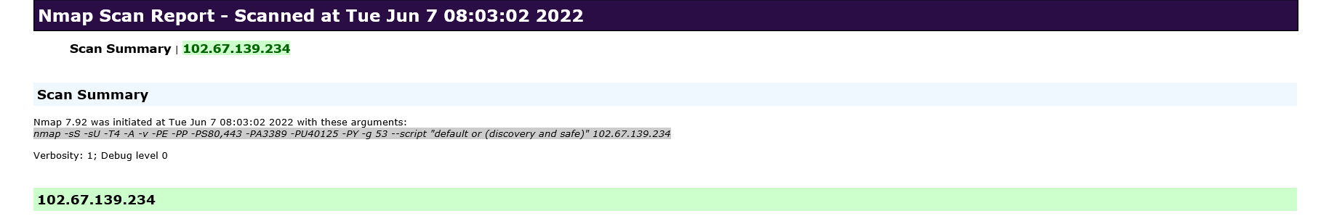

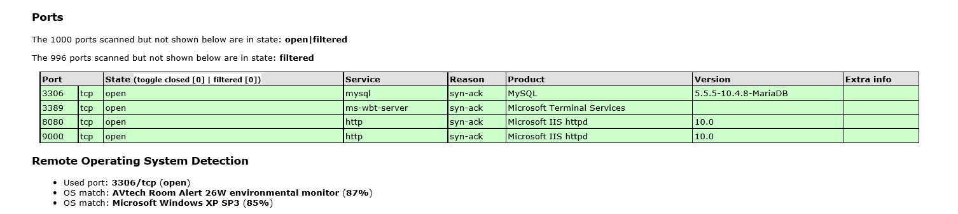

We Recommend closing RDP (3389) or either of the following perform RDP is Accessed

- VPN with Certicate (not username and password combination)
- Configure Local Firewall to only accept RDP connections from known source address
- Install 2FA i.e. Google Authenticator.

Web Application Testing

Exploiting vulnerabilities such as SQLi, XSS, CSRF, authentication flaws.

Database Exploitation

Testing where access is available to identify misconfigurations and vulnerabilities.

Active Directory

Testing for weak domain policies and credential storage flaws.
Example of Active Directory Bruce Force:

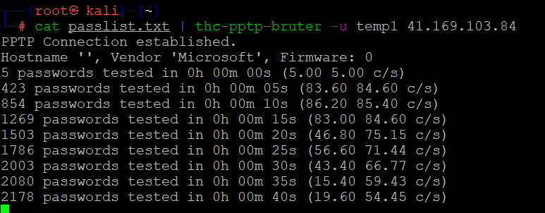

Administrator:500:aad3b435b51404eeaad3b435b51404ee:07c19e98f0ee02e10fce023c82d43c4d:

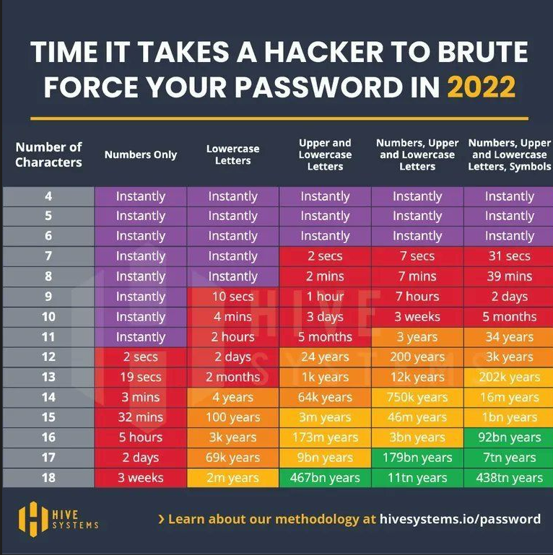

Wireless Network

Assessing AP security, encryption strength, and misconfigurations

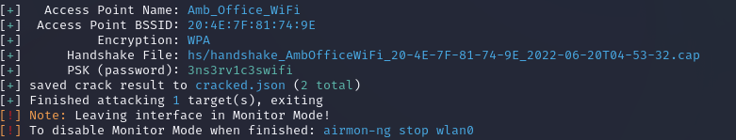

Project PLan
Considering Nam-mic’s specific requirements, the following structured approach will guide the penetration testing engagement. This methodology ensures thorough coverage of the defined scope, adherence to PSD-12 compliance, and alignment with industry best practices (OWASP Top 10, Greenbone, and international standards). All testing will be conducted after business hours (18:00–06:00), with at least 48 hours’ notice provided before commencement.
Please note that some tasks will run concurrently to optimize efficiency. A small contingency has been built into the plan to accommodate access dependencies and unforeseen delay.

Project Initiation

- Define and confirm the final scope of the penetration test in alignment with Nam-mic’s requirements.
- Obtain necessary approvals and testing authorizations from stakeholders.
- Validate testing exclusions: physical security, social engineering, and denial-of-service attacks on live systems.
- Confirm after-hours testing schedule and change control procedures.

Reconnaissance

- Conduct information gathering and reconnaissance of Nam-mic’s external environment.
- Perform open-source intelligence (OSINT) to map public-facing systems, domains, and related infrastructure.
- Identify potential attack vectors against:
  - External IP Range (41.190.84.130 – 41.190.84.158).
  - Banking and vending web portals.
  - API gateways and payment processing endpoints.

Vulnerability Scanning and Assessment

- Execute comprehensive vulnerability scans using Greenbone Enterprise and complementary tools.
- Identify and classify vulnerabilities across:
  - Web applications and portals.
  - Database systems (where access is provided).
  - Network infrastructure components.
  - Open ports and exposed services.
- Validate and prioritize vulnerabilities based on severity and potential business impact.

Exploitation

- Attempt to exploit identified vulnerabilities to determine the extent of risk.
- Apply OWASP Top 10 methodologies to test application-layer security.
- Target:
  - Authentication mechanisms (including resistance to brute force, credential stuffing, and bypass attempts).
  - Payment APIs and transaction flows.
  - Database security controls and query validation (where access is available).
- Document successful exploit attempts with controlled impact demonstrations.

Privilege Escalation

- Attempt to escalate privileges within compromised systems to simulate attacker persistence.
- Test for misconfigurations, weak controls, and privilege escalation flaws.
- Evaluate effectiveness of multi-factor authentication and access control measures.

Lateral Movement

- Assess ability to move laterally within the internal environment (where in-scope access is provided).
- Simulate pivoting from compromised nodes to gain unauthorized access to sensitive systems.
- Map lateral attack pathways and document weak isolation points.

Data Security & Exfiltration

- Test security controls preventing unauthorized access to financial and customer data.
- Attempt controlled data extraction from systems such as databases, APIs, and backup solutions.
- Validate encryption of sensitive data in transit and at rest.
- Document potential data leakage vectors.

Backup & Recovery Testing

- Assess security of Nam-mic’s backup and recovery systems.
- Validate encryption, retention policies, and alignment with PSD-12 compliance objectives.
- Confirm resilience of backup systems against unauthorized access and misuse.

Reporting & Risk Analysis

- Deliver a comprehensive report that includes:
  - Executive summary (business-level risk).
  - Detailed technical findings
  - Exploitation evidence and proof-of-concept results.
  - Risk rating aligned with industry standards (CVSS v3.1).
- Provide practical recommendations for remediation.
- Include analysis of geolocation-based restrictions, validating resilience when geo-locking is disabled.

Remediation & Follow-Up

- Conduct a remediation workshop with Nam-mic’s IT/security teams.
- Assist with prioritization and remediation planning.
- Provide validation (retesting) of patched vulnerabilities.
- Recommend continuous monitoring, patch management, and recurring penetration testing as part of Nam-mic’s security lifecycle.

DELIVERABLES AND OUTCOMES

The following deliverables will be provided as part of the Vulnerability Assessment and Penetration Testing (VAPT) engagement. The final reporting package will be comprehensive, regulator-ready.

Primary Deliverable

VAPT Report (Detailed with Findings):
A full penetration testing report inclusive of all technical findings, risk ratings, supporting evidence, and remediation guidance.

Report Component’s
The VAPT Report will include, but not be limited to, the following sections:
- Executive Summary Report
  - High-level overview for management and stakeholders.
  - Risk posture assessment and overall security rating.
- Scope of Testing
  - Clear definition of in-scope systems, IP ranges, applications, and databases tested.
  - Exclusions and constraints noted.
- Methodologies Used
  - Approach and frameworks applied (aligned with OWASP Top 10, NIST, Greenbone Vulnerability Management, etc.).
- Vulnerability Assessments
  - Detailed findings of identified vulnerabilities across endpoints, servers, databases, firewalls, and web applications.
  - Categorized by severity (Critical, High, Medium, Low).
- Port Mapping & Enumeration
  - Identification and documentation of open, filtered, and closed ports.
  - Validation of exposed services and potential attack vectors.
- Brute Force & Authentication Testing
  - Testing of password policies, lockout mechanisms, and authentication resilience.
  - Multi-factor authentication validation (where applicable).
- Separate Reports
  - Greenbone Vulnerability Report – Automated vulnerability scan results.
  - OWASP Web Application Report – Application security testing results against OWASP Top 10 risks.
- Risk Levels & Impact Ratings
  - Clear risk classification (Critical / High / Medium / Low).
  - Impact analysis aligned with compliance and business impact.
- Recommendations & Remediations
  - Prioritized technical and procedural recommendations.
  - Remediation guidance mapped to PSD-12, ISO 27001, and industry best practices.
- Conclusions
  - Final assessment of overall security posture.
  - Next steps and roadmap for continuous improvement.

- Presentation & Stakeholder Workshop (optional if required)
- Walkthrough of findings with both executive stakeholders and technical teams.
- Q&A session to ensure risks and recommendations are fully understood.
- Delivery of both the Executive Summary and Technical Report in a collaborative session.
- Retest and Validation Report (if required, post-remediation)
- Validation of fixes applied by the client’s technical team.
- Confirmation that previously identified vulnerabilities have been remediated.
- Updated technical report with a “clean bill of health” where applicable.

Risk Analysis for Cyber Penetration Testing Proposal

Objective

The objective of this risk analysis is to identify potential risks associated with conducting the penetration testing project for the client. This ensures that stakeholders understand the possible impacts and likelihood of risks, and supports decision-making, preparation, and mitigation strategies.

Risk Identification

- Unauthorized Access – Testing activities may uncover pathways that could unintentionally expose sensitive systems or data.
- Service Disruption – Testing of endpoints, firewalls, and network devices could inadvertently cause temporary service interruptions, degraded performance, or system crashes.
- Data Integrity & Loss – Vulnerability exploitation or testing may result in unintended data corruption or temporary unavailability if backups are not validated.
- Regulatory & Compliance Risks – Testing activities must align with applicable regulations (e.g., data protection, financial compliance) to avoid legal or reputational issues.
- False Positives & Negatives – Automated scanning may generate false results, leading to either wasted remediation effort or overlooked vulnerabilities.
- Critical System Dependencies – Testing backup/recovery systems, authentication, and databases introduces risks if these systems are not isolated or if dependencies are not properly managed.
- Reporting Sensitivity – Handling of test results and reporting may create risks of exposure if findings are not shared securely.

Risk Assessment

Risk | Likelihood | Impact
Unauthorized Access | Medium | High
Service Disruption | Medium | High
Data Integrity & Loss | Low | Medium
Regulatory & Compliance | High | High
False Positives/Negatives | Medium | Medium
Critical System Dependencies | Medium | High
Reporting Sensitivity | Low | Medium

Risk Mitigation

- Only in-scope systems are tested by implementing a formal pre-test checklist and client confirmation of approved assets. Exclusions (such as social engineering and DoS testing) will be documented and validated with the client before commencement.
- Access Controls – Limit test access to authorized personnel and follow strict authentication and approval processes.
- Change & Maintenance Windows – Conduct testing during pre-approved maintenance/testing windows to reduce operational disruption.
- Data Backup & Recovery Validation – Ensure all critical systems and databases have validated backups before testing begins.
- Compliance Alignment – Obtain written approvals and ensure testing is aligned with relevant compliance frameworks (e.g., PCI-DSS for payments, POPIA where applicable).
- Verification of Findings – Manually validate automated scanner results to minimize false positives/negatives.
- Controlled Exploitation – Exploitation activities will be carefully scoped and limited to avoid uncontrolled damage to production systems.
- Secure Reporting & Communication – All findings, evidence, and reports will be encrypted and shared only via approved secure communication channels.
- Change Control & Authorization: All testing will proceed only after written approval from designated client stakeholders. Any changes to scope will require updated authorization.
- Confidentiality & Data Handling: Sensitive client information will be protected under NDA and securely managed throughout the project lifecycle.
- Monitoring & Escalation: Testing activities will be monitored continuously. Any issue with potential service disruption will be escalated immediately to the client.
- Evidence Retention: Logs, screenshots, and other evidence will be securely retained for reporting and securely destroyed post-project where required by policy.

Risk Monitoring and Review

- Risks will be continuously monitored throughout the penetration testing project.
- Mitigation strategies will be reviewed at each project phase.
- Post-engagement, a lessons-learned review will be conducted to identify residual risks and refine future testing approaches.

RESOURCE REQUIREMENTS

Assessment Areas and Assigned Resources

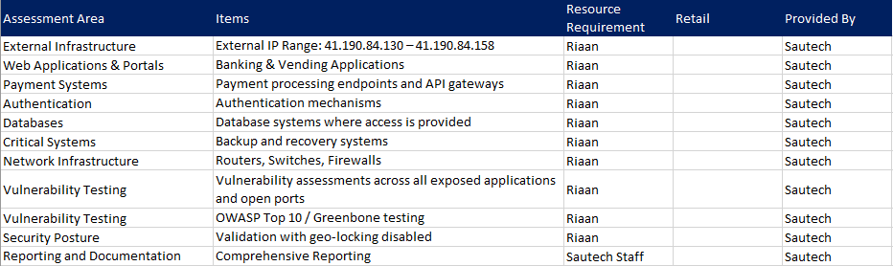

Detailed Recourse Requirements

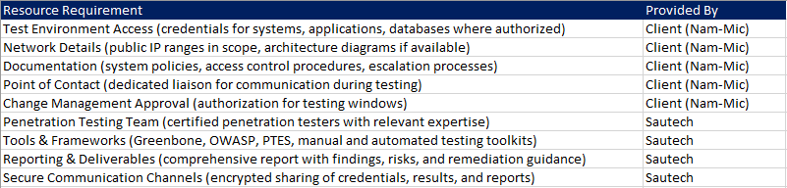

Key Personnel

The following key personnel from Sautech will be engaged for this project:

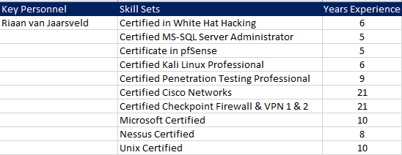

Cost Analysis

The following cost structure will be provided for Nam-mic:

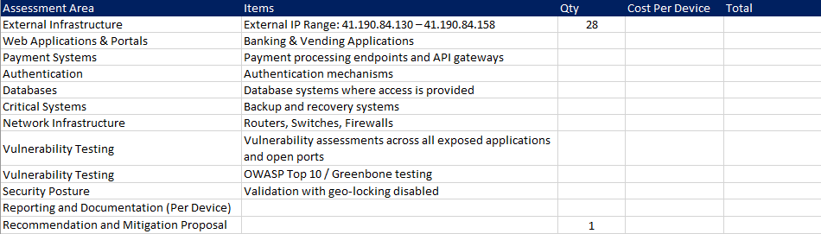

TERMS & CONDITIONS

Confidentiality

All information obtained during the engagement will be treated as strictly confidential and used solely for the purpose of conducting the penetration testing and vulnerability assessments.

Client Responsibilities

- The client is responsible for providing accurate and up-to-date system information, credentials, and documentation required for testing.
- The client must ensure that all necessary internal approvals, authorizations, and change controls are in place before commencement.

Testing Boundaries

- Only systems, applications, and networks explicitly listed in the agreed Scope of Work will be tested.
- Any additional systems identified during testing will require written approval before being included.

Liability

While every effort is made to minimize risk, penetration testing carries inherent risks of service disruption or system instability. Sautech will not be held liable for unintentional downtime, data corruption, or business impact unless due to proven negligence.

Compliance

Testing activities will align with relevant laws and regulations. The client must ensure that third-party approvals (e.g., cloud providers, hosted environments) are obtained if applicable.

Reporting and Ownership

All findings, reports, and recommendations remain the intellectual property of Sautech until full payment is received. Upon payment, the client receives full rights to use the reports internally.

Payment Terms

Payment is due as per the agreed commercial terms outlined in the cost analysis section. Delays in payment may result in withholding of reports or deliverables.

Validity

This proposal is valid for a period of 30 (thirty) days from the date of issue.

References / APENDICES

Sautech has delivered successful penetration testing engagements across financial services, banking, and payment providers in Southern Africa. Client-specific references and case study references below:

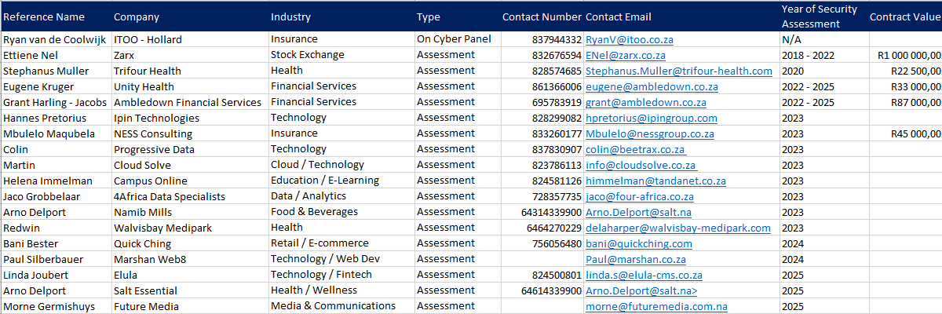

CONCLUSION
Sautech is committed to assisting Nam-mic in strengthening its cybersecurity posture by identifying vulnerabilities, assessing real-world risks, and providing actionable recommendations for remediation.
This proposal outlines a structured and controlled penetration testing approach aligned with industry best practices, with clearly defined objectives, scope, methodologies, risk safeguards, and deliverables, the project will not only uncover vulnerabilities but also enable the client to build a sustainable and secure IT environment.
We look forward to partnering with Nam-mic to proactively address current and emerging cyber threats, ensuring resilience, compliance, and protection of critical business operations.

AUTHORISATION

This proposal has been prepared and approved by Sautech (Pty) Ltd for submission to
Nam-mic.

20th August 2025 – Krugersdorp, Gauteng, South-Africa

______________________________
HC van Jaarsveld
Director
Sautech (Pty) Ltd

